Sustainable Intensification

### SQ1: Is farming with Silvopastoral Systems in Caquetá a from of Sustainable Intensification?

The following chapter compares the means of stocking rate, annualmilk yield per hectare, annual abour days per hectare and the distance of farmers with SPS and of farmers with only conventional pasture. The analysis is executed in Rstudio using R Notebook. The necessary code for the analysis is displayed in boxes.

library(tidyverse)  
library(ggplot2)  
load("Dataframes/si.df.rda") # Load Dataframe  
si.df <- filter(si.df, land_type=="Lomerío (lomas, mesas y vallecitos" & SPS!="NA")

At first necessary libraries and the dataframe si.df are loaded. Data is filtered to only contain land_type “hills” and no NA-values in the SPS variable.The dataframe contains only farms with land_type hills (“Lomerío”). 68 farmers have only conventional pastures. 15 farmers have SPS.

The two figures below show a first visualization of the data. A point cloud of annual milk yield per hectare and distance and a point cloud of annual labour hours per hectare and the stocking rate are displayed. The green points are the farmers that have SPS. It is already obvious that the stocking rate, the annual milk yield per hectare and the annual labour days per year are not normaly distributed. The T-test assumptions are independent observations, normal distribution and metric values. Therefore a transformation of the data is necessary. When comparing SPS as conventional farmers (green and red points) no clear clusters are visual. Already now it seems unprobable that both groups of farmers differ in the measures of intensity but the t-test will give clearer results. 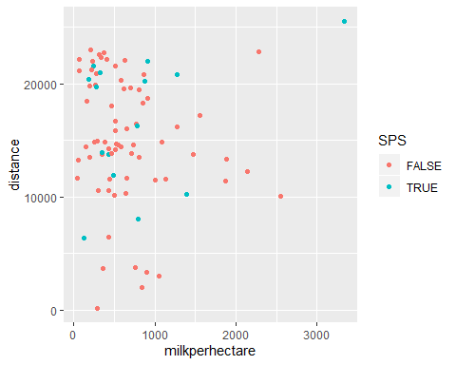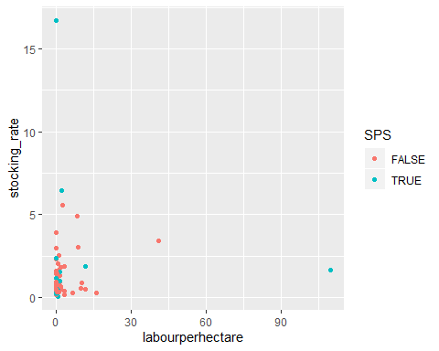

**Stocking rates** The histograms and QQplots of the stocking rates of conventional and SPS farmers are displayed. Obviously the stocking rates are not normally distributed but skewed to the right. 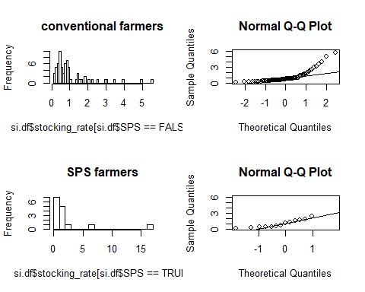 The stocking rates are log-transformed to have a more normal distribution. Below are the are histograms and QQ-plots that show a better result of the transformed variable.

si.df$stocking_rate.log <- log(si.df$stocking_rate)

Histograms and QQplots of log stocking rates 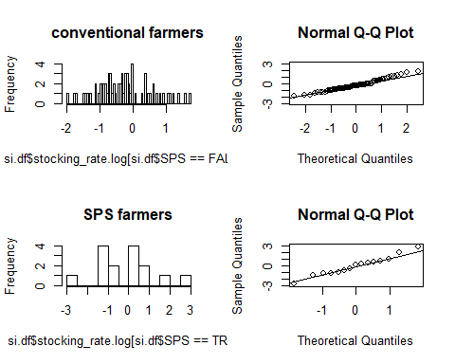 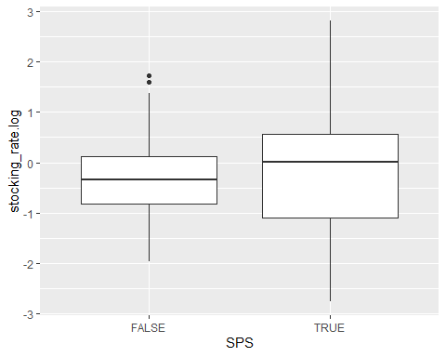 The boxplots of log stocking rates of conventional and SPS farmers show a higher median for SPS farmers but very high variances. The two-sided t-test statistics are displayed below.

stock.t_test <- t.test(  
 x=si.df$stocking_rate.log [si.df$SPS==FALSE],  
 y=si.df$stocking_rate.log [si.df$SPS==TRUE])  
stock.t_test

##   
## Welch Two Sample t-test  
##   
## data: si.df$stocking_rate.log[si.df$SPS == FALSE] and si.df$stocking_rate.log[si.df$SPS == TRUE]  
## t = -0.48169, df = 16.172, p-value = 0.6365  
## alternative hypothesis: true difference in means is not equal to 0  
## 95 percent confidence interval:  
## -0.9701064 0.6106179  
## sample estimates:  
## mean of x mean of y   
## -0.2865579 -0.1068137

print("Mean Stocking rates of conventional and SPS farmers:")

## [1] "Mean Stocking rates of conventional and SPS farmers:"

exp(stock.t_test$estimate)

## mean of x mean of y   
## 0.7508436 0.8986931

Conventional farmers have a mean stocking rate of 0.7508436. SPS farmers have a mean stocking rate of 0.8986931. Even though the mean stocking rates (geometric means) of SPS farmers are higher they don’t differ significantly. The Null-hypotheses (both means are the same) can not be rejected.

**Annual milk yield per hectare** The same procedure is followd for annual milk yield per hectare. Histograms and QQplots show a skewed distribution so a log transformation is performed. Boxplots show very similar results for both farmers groups but the median for conventional farmers is a little higher. 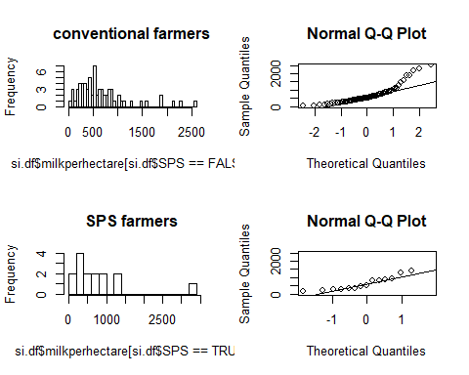 Log transformation for more normal distribution

si.df$milkperhectare.log <- log(si.df$milkperhectare)

Histograms and QQplots of log stocking rates 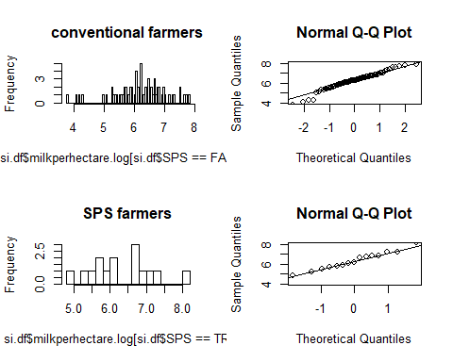 **Boxplot of log milk yield**

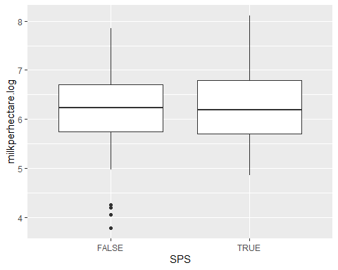 **T-test comparing mean milk yield per hectare of SPS and conventional farmers**

my.t_test <- t.test(  
 x=si.df$milkperhectare.log[si.df$SPS==FALSE],  
 y=si.df$milkperhectare.log[si.df$SPS==TRUE])  
my.t_test

##   
## Welch Two Sample t-test  
##   
## data: si.df$milkperhectare.log[si.df$SPS == FALSE] and si.df$milkperhectare.log[si.df$SPS == TRUE]  
## t = -0.4109, df = 20.246, p-value = 0.6855  
## alternative hypothesis: true difference in means is not equal to 0  
## 95 percent confidence interval:  
## -0.6136649 0.4115578  
## sample estimates:  
## mean of x mean of y   
## 6.200096 6.301150

print("Mean annual milk yield per hectare of conventional and SPS farmers:")

## [1] "Mean annual milk yield per hectare of conventional and SPS farmers:"

exp(my.t_test$estimate)

## mean of x mean of y   
## 492.7965 545.1984

The two-sided t-test shows a higher annual mean milk yield per hectare for SPS farmers. However results are not significant as the Null-hypothesis cannot be rejected.

*Annual labour days per hectare*  The prdocedure is repreated for annual labour days per hectare. Histograms and QQplots of annual labour days per hectare and of the log-transformation are shown below. A log transformation of log(x+0.01) is chosen to avoid infinitive values for farmers with 0 labour days. The boxplot shows very similar results to the annual milk yield. 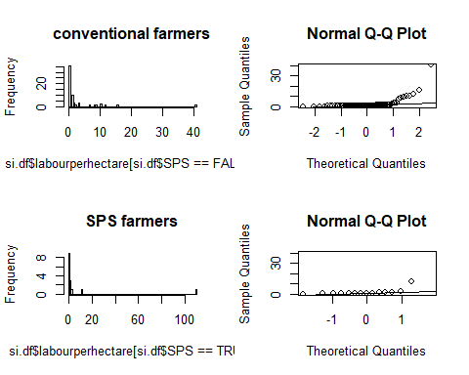

Log transformation for more normal distribution

si.df$labourperhectare.log <- log(si.df$labourperhectare+0.01)

Histograms and QQplots of log stocking rates 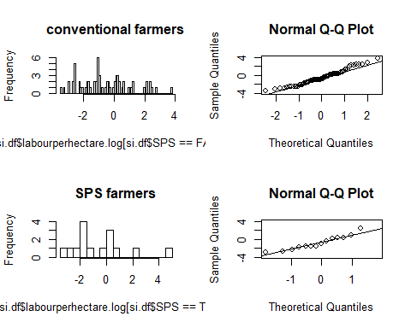 **Boxplot of annual labour days per hectare** 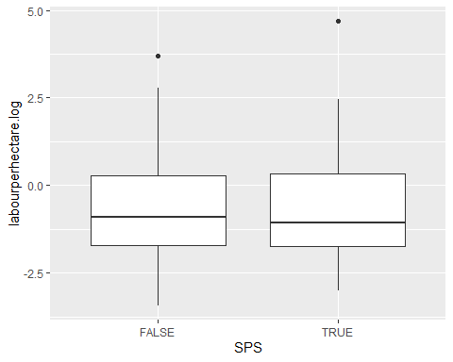

**T-test comparing mean labour hours per hectare of SPS and conventional farmers**

lh.t_test <- t.test(  
 x=si.df$labourperhectare.log[si.df$SPS==FALSE],  
 y=si.df$labourperhectare.log[si.df$SPS==TRUE])  
lh.t_test

##   
## Welch Two Sample t-test  
##   
## data: si.df$labourperhectare.log[si.df$SPS == FALSE] and si.df$labourperhectare.log[si.df$SPS == TRUE]  
## t = -0.13306, df = 17.937, p-value = 0.8956  
## alternative hypothesis: true difference in means is not equal to 0  
## 95 percent confidence interval:  
## -1.272137 1.120631  
## sample estimates:  
## mean of x mean of y   
## -0.5760283 -0.5002750

print("Mean annual labour days per hectare of conventional and SPS farmers:")

## [1] "Mean annual labour days per hectare of conventional and SPS farmers:"

exp(lh.t_test$estimate)-0.01

## mean of x mean of y   
## 0.5521266 0.5963639

Mean annual labour days per hectare are slightly higher for SPS farmers than for conventional farmers. The difference however is not significantly high enough to reject the NUll-hypothesis of both means beeing equal.

*Distance* The diagnosis is executed for distance as well. Histograms, QQplots and boxplots are displayed below. Distance is not log-transformed. 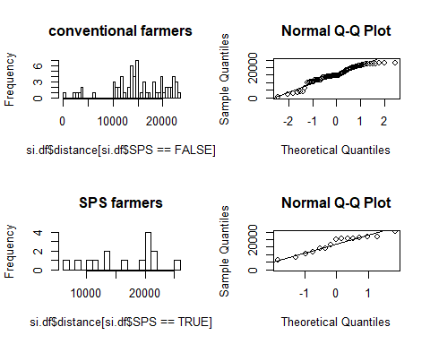

**Boxplots of distance**

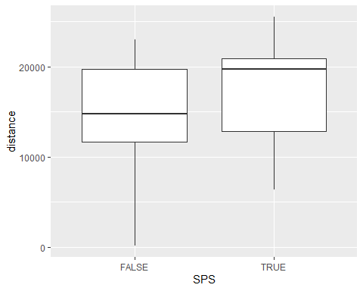

**T-test comparing mean distance of SPS and conventional farmers**

d.t_test <- t.test(  
 x=si.df$distance[si.df$SPS==FALSE],  
 y=si.df$distance[si.df$SPS==TRUE])  
d.t_test

##   
## Welch Two Sample t-test  
##   
## data: si.df$distance[si.df$SPS == FALSE] and si.df$distance[si.df$SPS == TRUE]  
## t = -1.0514, df = 20.245, p-value = 0.3055  
## alternative hypothesis: true difference in means is not equal to 0  
## 95 percent confidence interval:  
## -5120.033 1686.631  
## sample estimates:  
## mean of x mean of y   
## 15055.63 16772.33

The mean distance indicates that SPS farmers are located a little further from the highway. Again however the difference is not significant enough to reject the Null-hypothesis that both means are the same.

In summary the chosen measures for intensity (stocking rate, annual milk yield per hectare, annual labour hours per hectare) as well as the distance did not show significant differences for conventional farmers and SPS farmers. The median and the mean for stocking rates of SPS farmers are higher compared to conventional farmers. The distance shows the same tendency. The means for annual labour days and for annual milk yield per hectare are higher for SPS farmers but the median is lower compared to conventional farmers.